

font option #2.png

Updated Project Plan for Round 2 [2011]

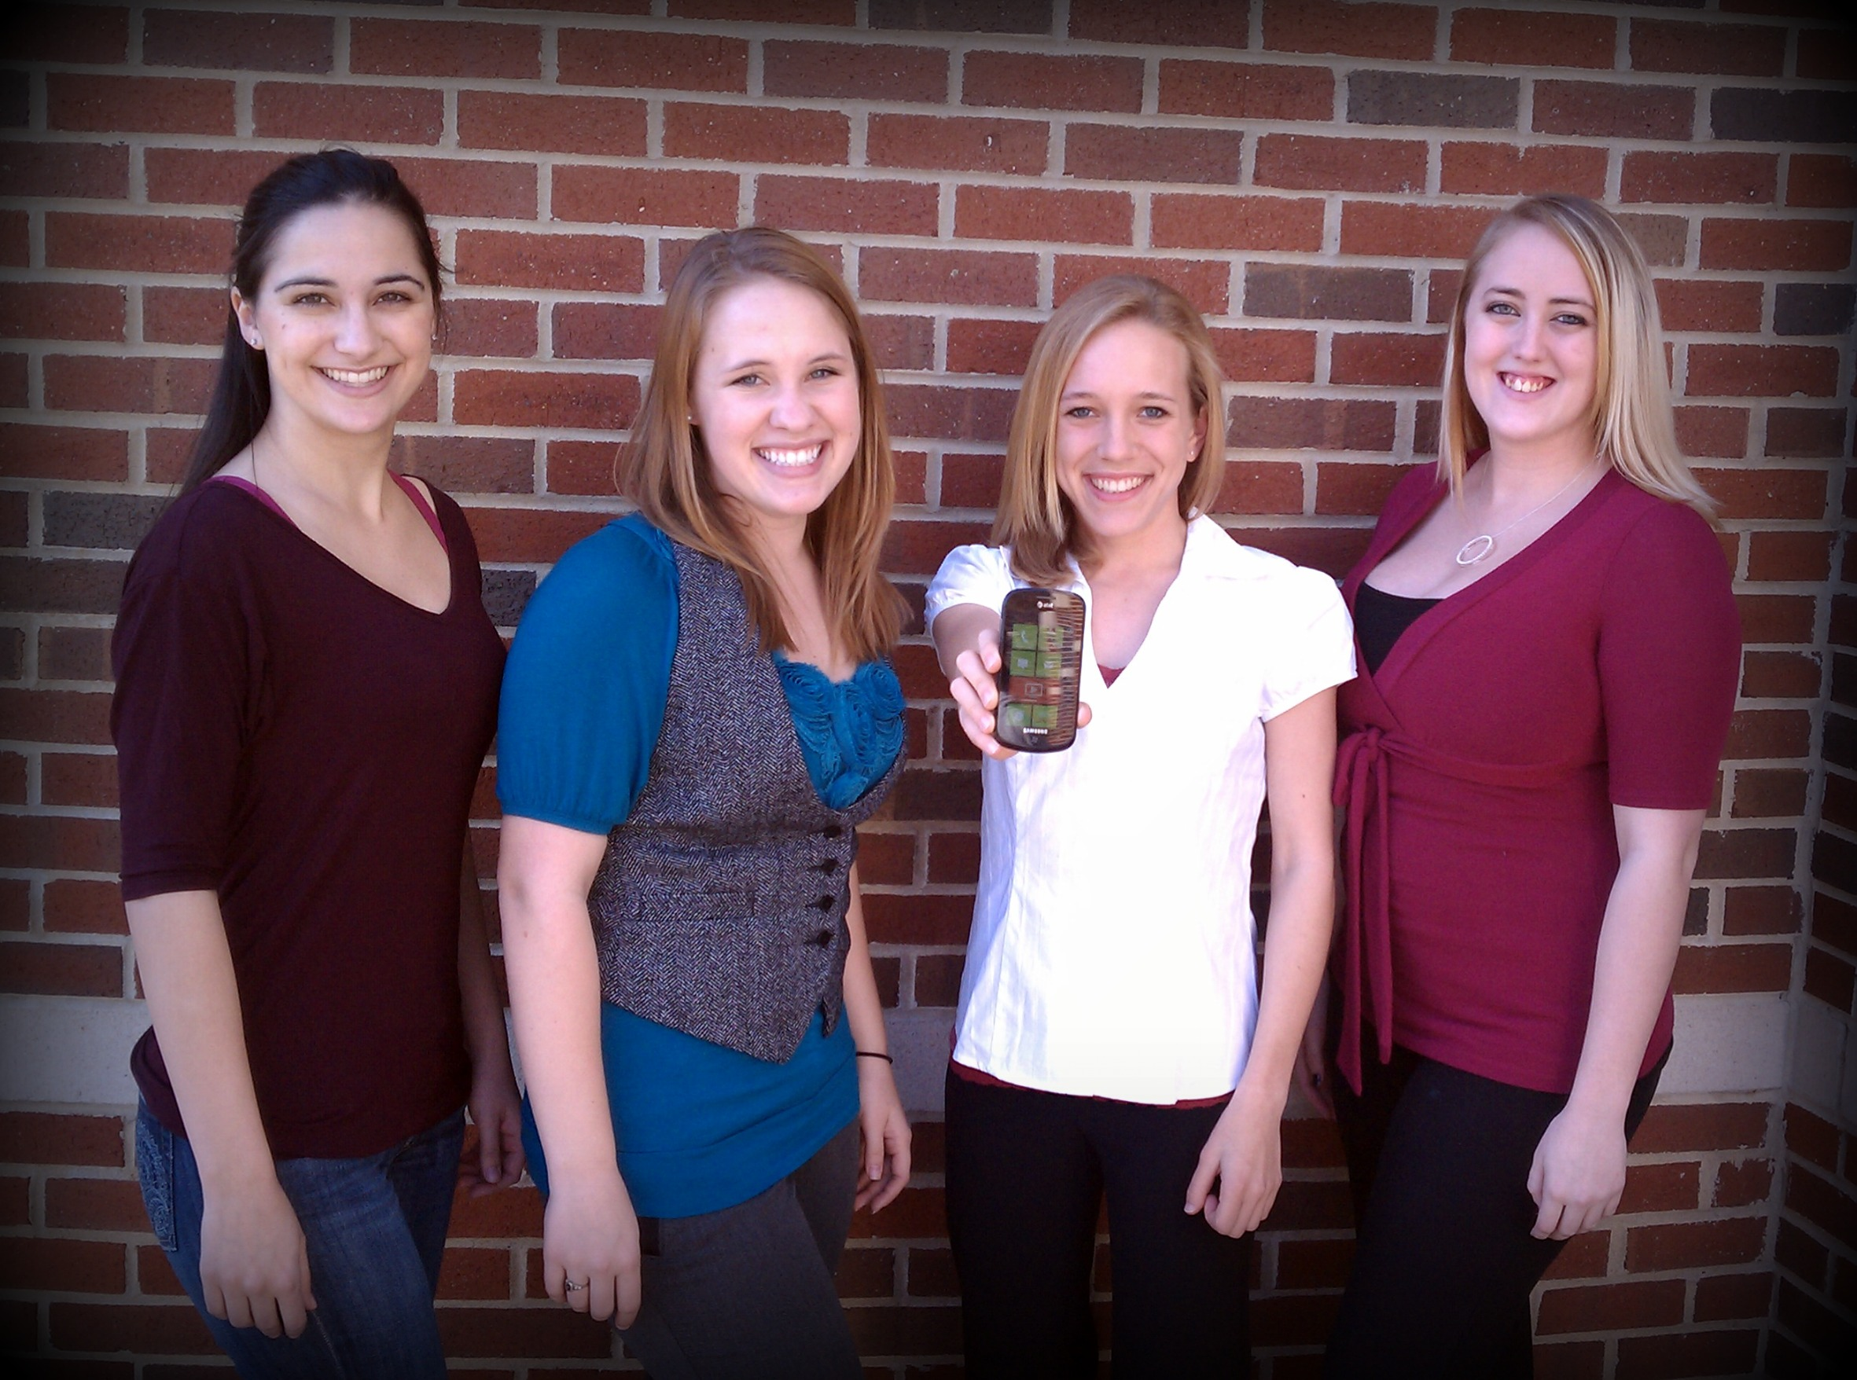

Table of Contents

The Problem ……………………………………………………………………………………………………..…….……..3

Fitting the Imagine Cup Theme ………………………………………………………………………………….…....4

Our Solution …………………………………………………………………………………………………………….….….5

The Technology ………………………………………………………………………………………………………….…...6

Activity Diagrams …..……………………………………………………………………………..………….................7

Business Viability ..…………………………………………………………………………………………………………10

Meet the Team ……………………………………………………………………………………………………………....11

The Problem

Every 7 minutes someone in the United States loses their sight. According to the Research to Prevent Blindness, there are fifteen million blind and visually impaired people in the United States alone. The Braille Institute states that visual impairments affect the lives of nearly five million preschool-age children and approximately twelve million school-age children. To put those numbers into perspective, that would mean that one in twenty children age three to five and twenty-five percent of children from the ages of six and seventeen are affected by some kind of vision problem. With a visual impairment, one has to discover a way to navigate through the world. Only two percent among the legally blind use a guide dog and only thirty-five percent use a directional long-cane to guide them. A large percentage of the visually impaired have a need for an alternative guide. There is a deep need for new research that can advance the technology offered to those who are challenged by mobility and navigational restrictions. Several technology options exist to assist the visually impaired in navigating outdoors. Such technologies are often based on GPS and location-aware sensing. However, such an approach does not work indoors when the satellite signal strength is too low. If those affected by visual impairments had access to technology that could help them navigate throughout buildings to increase the perception of their surroundings, they could be assisted with common daily tasks that they encounter related to work or general activities.

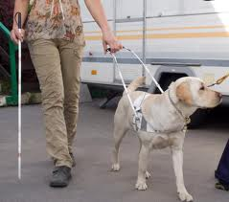[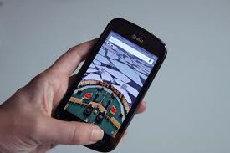](http://www.google.com/imgres?imgurl=http://mydailygadget.mdg.netdna-cdn.com/wp-content/uploads/2010/11/samsung-focus-review-35-bing-search.jpg&imgrefurl=http://www.mydaily-gadget.com/news/2897-att-samsung-focus-release-date-specs-and-price-announcedwp7-included&usg=__YAyedgrP_42779iDcQu8Um9AYaE=&h=312&w=468&sz=33&hl=en&start=0&zoom=1&tbnid=HRVTKvPgNwCL3M:&tbnh=133&tbnw=177&ei=-tVaTbzhJdKltwen5fW7Cw&prev=/images?q=samsung+focus&um=1&hl=en&sa=N&rlz=1T4GZAZ_enUS368US369&biw=1895&bih=807&tbs=isch:1&um=1&itbs=1&iact=hc&vpx=987&vpy=210&dur=2032&hovh=183&hovw=275&tx=133&ty=92&oei=09VaTdmwGYKB8gazxJCBDQ&page=1&ndsp=40&ved=1t:429,r:15,s:0)

Fitting the Imagine Cup Theme

This project is focused on a Windows Mobile Application that will work as a navigation system to help the visually impaired maneuver within buildings. It addresses one main problem identified as a Millennium Goal – universal education. Living life with a physical disability has its own struggles in and of itself. But with this application, there is the potential to give so many people another chance at their dreams. With Digital Eyes, a person with visual impairments could have the confidence to take their education to the next level. It could even be the deciding factor for some to attend college, giving them a sense of independence. The overall quality of life for those with visual impairments can be improved greatly by extending this system and adding the extra functionality for all buildings at any campus location or any building. Public locations, such as shopping centers, libraries, and government buildings, would be navigable and accessible to the visually impaired. No longer would they be challenged with guessing the location of obstacles to find their desired location. They can walk right to it.



Solution Design & Innovation

Our project is a Windows Phone 7 application that assists the visually impaired in navigating inside buildings. Originally, we had planned on the application interfacing with posted Microsoft Tags and guiding the user to their specified destination inside of a building. This destination includes common features of the building such as restrooms, or to a more specific location, such as the room number. However, we have been experiencing issues with the Microsoft Tag technology and have temporarily transitioned to the use of QR codes. A challenge is that the launcher can be used for many things, but not the Tag reader. We hope to return to the Tag technology through interaction with Microsoft Senior Engineers.

Our product is unique for several reasons. Although GPS is included on almost every Smartphone, navigation within buildings is not currently well supported. With Digital Eyes, we are combining indoor navigation using tag technology and the phone’s on-board accelerometer to create a more interactive experience for the user. A user of our technology will be able to hear information about rooms and other points of interest within a building. Our product also allows users to set restrictions on their navigation around the building, such as avoiding stairs. Although Digital Eyes is directly targeted towards those with visual impairment, the application may be used by anyone who needs to find their way around an unfamiliar structure.

The experimental evaluation of our project will be performed by: 1) classmates who will use the system blindfolded, and 2) students on our campus, identified by the Office of Disability Services, who are among those in the target population of vision impaired students.

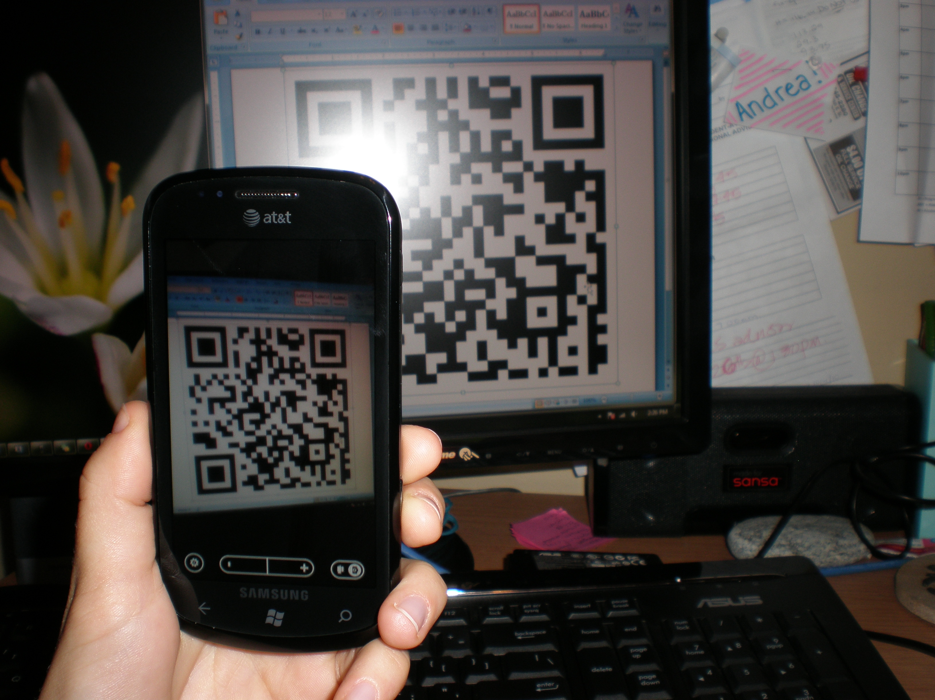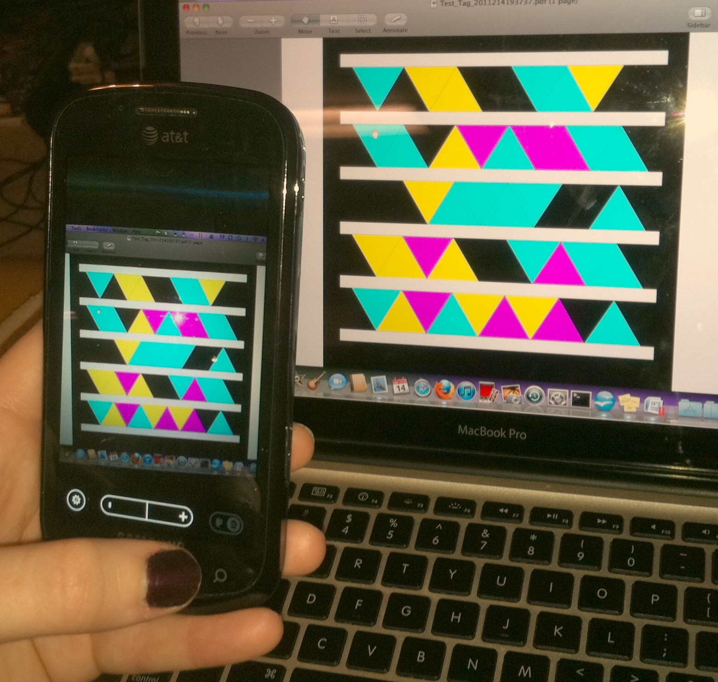

Technical Architecture & User Experience

The technology we will be using includes Microsoft Tag Reader, Microsoft Tags, voice recognition, and a phone with the Windows Phone 7 operating system. Temporarily, we will be using QR codes instead of Microsoft Tags. By using these technologies, our project can enable those who are visually impaired to access navigation information and directions to desired areas within a building. Microsoft Tags and QR codes both present an easily accessible option to the user that is free of cost through a download on their phone. The tag meaning is stored in the cloud. The user will need to have internet access to obtain the data stored through the tag. These tags will contain free-form text with information on the area where the tag is scanned. Examples include room numbers, bathrooms, elevators, stairs, and atriums. This free-form text is read to the user through the Windows Phone text-to-speech capability. The user will then be able to speak to the phone to answer a directional question, return to navigating the building, or exit the application. If they choose to ask a question, they will speak key words into the phone (e.g., “find bathroom,” or “find room 123”) and will be given turn-by-turn directions audibly from the phone. In our current prototype, we have hardcoded the QR code reader and plan to demonstrate the other functionality. Although the QR code features are not yet implemented, we plan to have these developed soon.

We have developed an algorithm used to determine the distance from the current location in the building to some other desired location. In addition to the Microsoft Tag technology and QR codes, we will use the accelerometer to assist in estimating the user location between tag scans. We choose not to use the GPS because of the challenge of receiving a strong GPS signal within the building, which would hinder tracking of the user within the building. We plan to create a generalization for the algorithms and mapping so one could use the Tag system for any building, not just the original building at the University of Alabama. This enhancement will involve use of a domain-specific language for describing the layout of the building. Such meta-information will be retrieved by the application before start up.

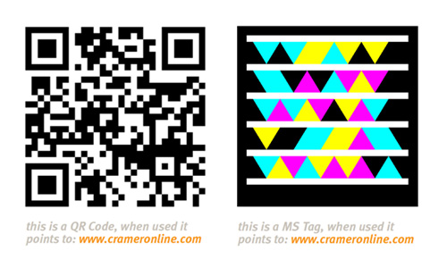

Activity Diagrams

***Overall Activity Diagram***

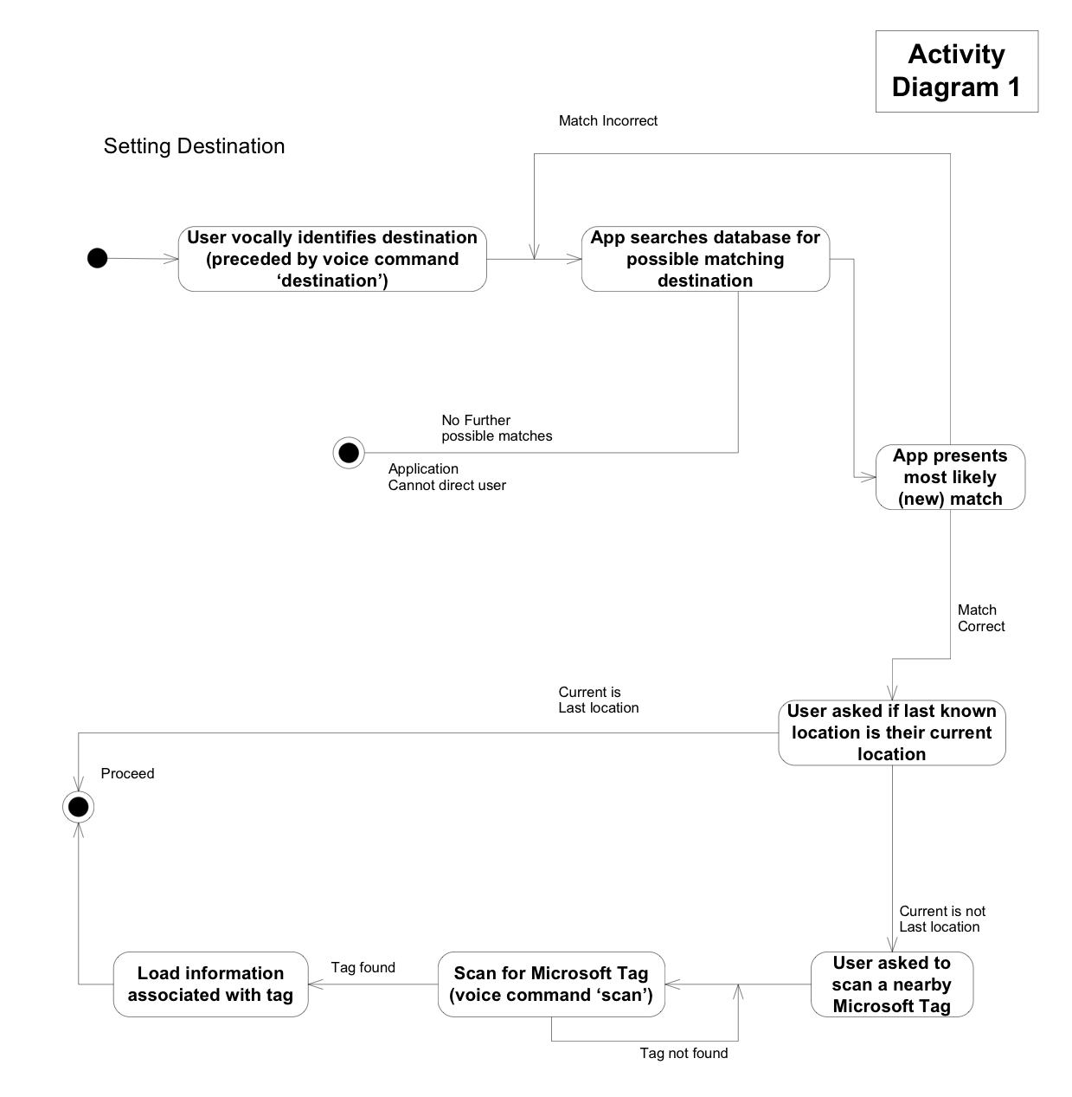

## *Activity Diagram for Path Calculation*

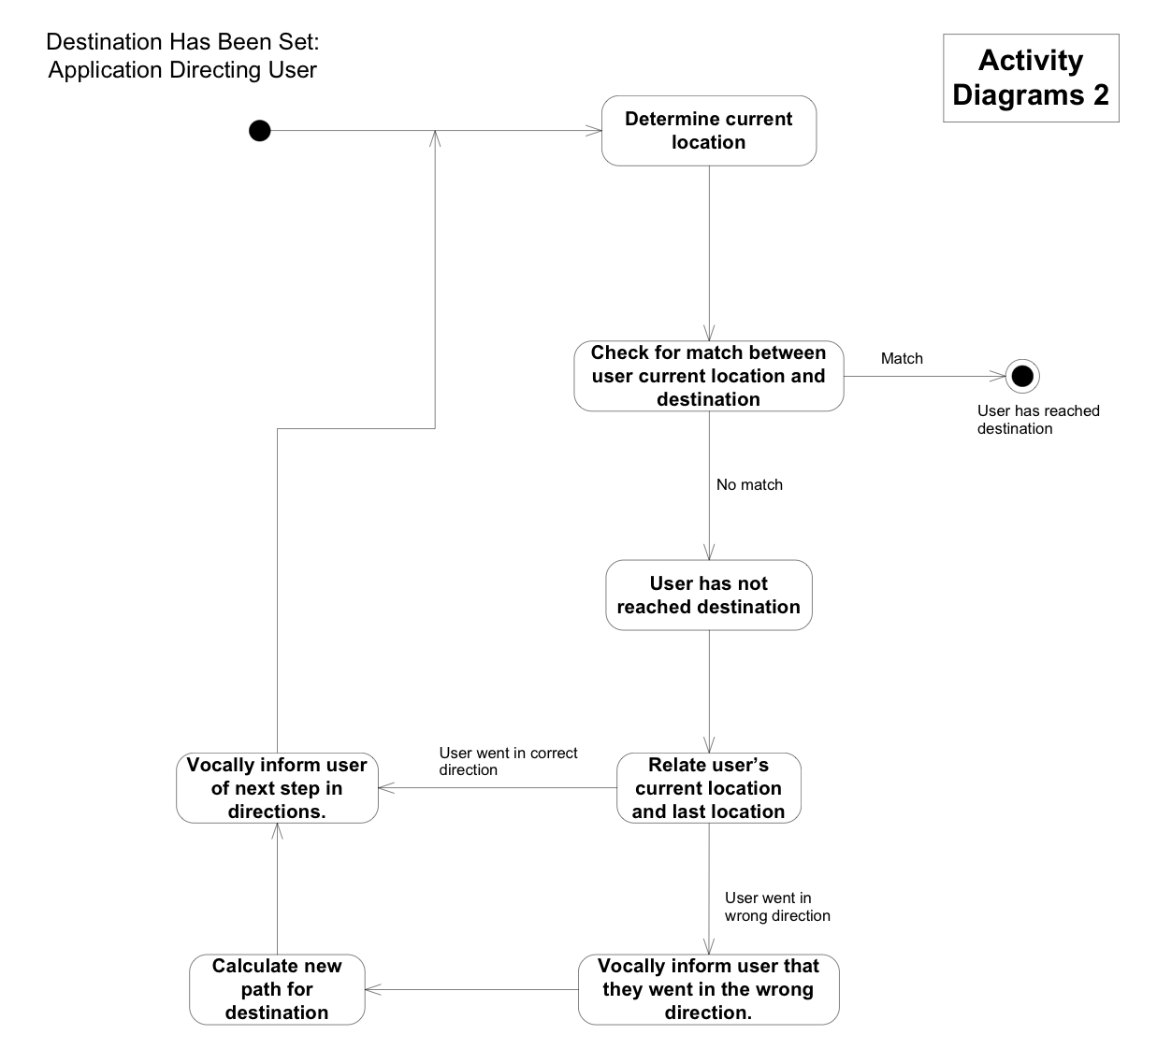

***Activity Diagram for Determining Current Location of User***

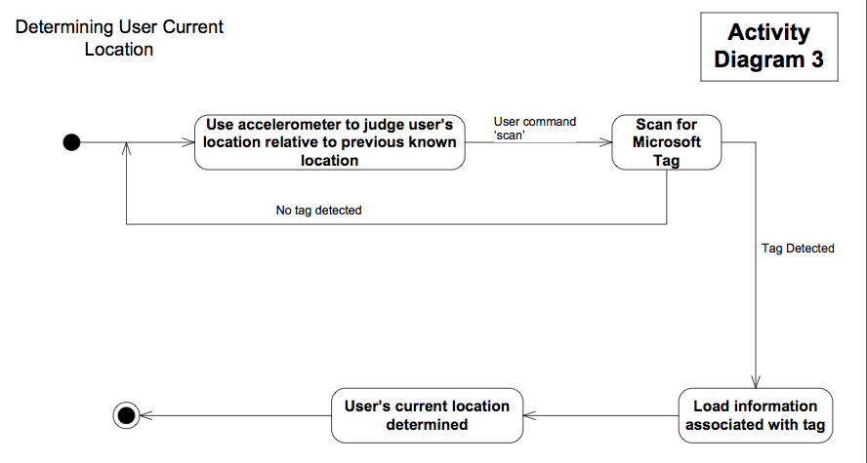

Business Viability

The Digital Eyes application will be available as a free download via the Windows 7 App Marketplace. Digital Eyes will be easy to download and configure. For the initial implementation there will be no configuration needed, the application will be preloaded with the maps and Microsoft Tags or QR codes for a specific building on our campus (e.g., a building in the Science Engineering Complex on the University of Alabama campus). In the final implementation, to use the application, the user will simply scan the Microsoft Tag or QR codes at the entryway to any building which has been tagged. This is the entire configuration that the user will need to perform before the application will work properly and will cause the application to automatically reference the appropriate map and Microsoft Tags or QR codes for that building.

Our Digital Eyes application will be used mainly by the visually impaired as a navigation aid inside of buildings. It intends to make navigation easier for those with partial or total visual disability. The application will use vocal cues to interact with the user. The user will issue voice commands to the application and the application will respond with verbal directions. Though the application’s core impact will be focused toward helping the visually disabled gain independence and mobility, this does not preclude others from using the application. Vocal directions also could be used by sighted users. The application could be used by anyone who needs to find their way through an unfamiliar or confusing building complex. The application's directions could also be very useful for those who are frequently lost inside of buildings.

This application has great potential for future expansion and additions. One possible addition is an onscreen map that follows the user’s movements inside of the building. This will be useful for users with partial or no vision impairment, giving them additional information about their environment and final destination. An onscreen map would also be useful if the user wishes to share the application’s directions with a sighted person (e.g., a sighted person who is new to the building and trying to locate a specific room). Another possible extension is the addition of warnings about possible safety risks inside the building. The user could be warned vocally about dangers which would otherwise be unknown to the visually disabled. Examples of this would be posted warnings signs, open stairwells, or any other possible dangers in the building.

Digital Eyes has the potential to be a transformative technology offering practical capabilities as a navigational aid for the visually disabled. There are also many intriguing and extremely viable options for future expansion of the application.

Meet the Team

**Leah Boling**

Leah was born in Nashville, TN. She began her college career in the Fall of 2008. Since then, she had the privilege of working on a Smartphone application, mentoring freshmen in Python, and working with a professor on a research project. She will graduate from the University of Alabama this May with a Bachelors of Science in Computer Science. Leah and her husband plan to move to Pennsylvania upon graduation where she will begin her professional career in Software Engineering.

**Melissa Bowman**

## Melissa is in her 5th and final year of her Bachelor of Science degree in Computer Science at the University of Alabama. She has been a member of the Association for Computing Machinery throughout her college career. Melissa had the privilege of working on a project that harvested perishable metadata through the use of Media Wiki, allowing scientific files to be uploaded, in the field, to a website that could then be tagged, searched, downloaded and saved. She has also been an active member of Mu chapter of Theta Tau, the Co-ed Professional Engineering Fraternity on campus, for three years.

## Andrea Torske

## Andrea is a junior Computer Science major at the University of Alabama. She is a member of the University Scholars program and is working toward both her Bachelor’s and Master’s degrees simultaneously. She worked with Dr. Wenjun Zeng at the University of Missouri on a National Science Foundation funded project (CSRF Protector) as an undergraduate student researcher. While at the University of Alabama she has also worked as a Teaching Assistant in beginning computer science courses. She has been a member of the cross-country and track teams at Alabama during her entire college career.

## Elizabeth Williams

## Elizabeth is a junior Computer Science major at the University of Alabama. She has participated in research on the National Science Foundation funded project Text-to-Art with Dr. Nicholas Kraft. She is also a member of University Stewards, an organization that assists the UA Admissions Office in recruiting new students. Throughout her college career, she has mentored students in the CS 150 Beginning Programming course, volunteered at a local elementary school, and led groups of incoming freshmen to do service projects. She loves photography, traveling, and playing with her dogs.